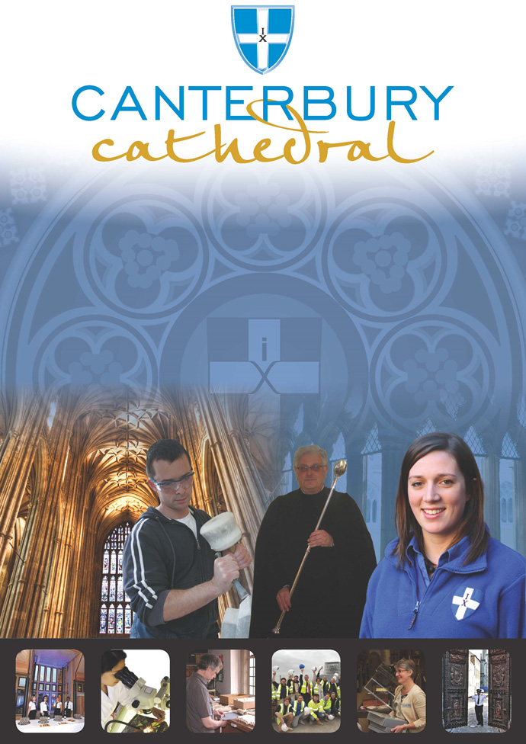

PROFILE OF CANTERBURY CATHEDRAL
St Augustine, the first Archbishop of Canterbury, arrived on the coast of Kent as a missionary to England in 597 AD. He came from Rome, sent by Pope Gregory the Great. It is said that Gregory had been struck by the beauty of Angle slaves he saw for sale in the city market and dispatched Augustine and some monks to convert them to Christianity. Augustine was given a church at Canterbury (St Martin’s, after St Martin of Tours, still standing today) by the local King, Ethelbert whose Queen, Bertha, a French Princess, was already a Christian. This building had been a place of worship during the Roman occupation of Britain and is the oldest church in England still in use. Augustine had been consecrated a bishop in France and was later made an archbishop by the Pope. He established his seat within the Roman city walls (the word cathedral is derived from the Latin word for a chair ‘cathedra’, which is itself taken from the Greek ‘kathedra’ meaning seat.) and built the first cathedral there, becoming the first Archbishop of Canterbury. Since that time, there has been a community around the Cathedral offering daily prayer to God; this community is arguably the oldest organisation in the English speaking world. The present Archbishop, The Most Revd Justin Welby, is 105th in the line of succession from Augustine.
Augustine’s original building lies beneath the floor of the nave– it was extensively rebuilt and enlarged by the Saxons, and the Cathedral was rebuilt completely by the Normans in 1070 following a major fire. There have been many additions to the building over the last nine hundred years, but parts of the quire and some of the windows and their stained glass date from the 12th century.
By 1077, Archbishop Lanfranc had rebuilt it as a Norman church, described as “nearly perfect”. A staircase and parts of the North Wall – in the area of the North West transept also called the Martyrdom – remain from that building.
During the Second World War, the Precincts were heavily damaged by enemy action and the Cathedral’s Library was destroyed. Thankfully, the Cathedral itself was not seriously harmed, due to the bravery of the team of fire watchers, who patrolled the roofs and dealt with the incendiary bombs dropped by enemy bombers.
Today, the Cathedral stands as a place where prayer to God has been offered daily for over 1,400 years; nearly 2,000 services are held each year, as well as countless private prayers from individuals. The Cathedral offers a warm welcome to all visitors – its aim is to show people Jesus, which we do through the splendour of the building as well as the beauty of the worship.

THE WORK OF THE CATHEDRAL
The work of the Cathedral is carried out by over 300 paid staff, supported by some 500 volunteers. The ‘corporate body’ responsible for the management of the Cathedral is the Chapter of Canterbury who are advised by the Cathedral Council and the College of Canons.

The Chapter of Canterbury (Chapter)
The Chapter are responsible for all aspects of the day-to-day management of the Cathedral. Chapter comprises the Dean, the Residentiary Canons, the Receiver General and four additional persons appointed by the Archbishop.

The Cathedral Council
The Council represents the Cathedral community as well as the wider local and regional community. It has 20 members, drawn from a wide variety of organisations. Its duty is to further and support the work of the Cathedral Church in spiritual, pastoral, evangelistic, social and ecumenical areas.

The College of Canons
The College of Canons is composed of 30 Honorary, Lay and Provincial Canons, appointed by the Archbishop and it supports the life of the Cathedral in many different ways.

The Cathedral Trust
The Cathedral Trust is a separate charity that is solely for the benefit of the Cathedral. Since 1974, it has assisted with the restoration, maintenance and improvement of the fabric and contents of Canterbury Cathedral and the provision, promotion and encouragement of music
The Cathedral is well-known all over the world and we welcome more than 1 million visitors and worshippers every year. The Cathedral is more than just a beautiful old building and heritage site; it is a working, living church which maintains a tradition of welcome and worship that has been practiced here for over 1400 years.

Friends
The Friends of Canterbury Cathedral was founded in 1927 by the distinguished scholar and poet Dean George Allen Kennedy Bell. The Organisation was the first of its kind in the world.
The Friends are the Cathedral’s fan club. Admirers of the building, its history and its community, Friends are a part of the Cathedral and work together to preserve it forever, contributing financially - and directly – to many individual and vital projects.

The Cathedral Shop
The Canterbury Cathedral Shop is a large gift shop in the heart of the city of Canterbury. It has an impressive range of high quality gifts, mostly British, and their own exclusive award winning designs.
The Shops wide range of merchandise includes replica historical artefacts, books and CD’s of the world-famous Canterbury Cathedral choir.

THE CANTERBURY JOURNEY

The Canterbury Journey will achieve a radical transformation in the accessibility and sustainability of Canterbury Cathedral. It will safeguard an iconic building which embodies England’s story, increase the number and broaden the range of those who journey to it, and enrich their experience.

A new Welcome Centre with a free Viewing Gallery of one of Europe’s most important churches and a dedicated Community Space. New trails will guide visitors through the Cathedral and its newly landscaped Precincts, interpreting their journey and revealing unseen treasures from Canterbury’s past. New visitors (including children and families) will join the journey as a programme of engagement and outreach to schools and communities unfolds. A new pass scheme will swell the company of contemporary pilgrims and deepen the Cathedral’s relationship with its neighbours. And the fabric of the western end of the Cathedral, currently endangered, will be restored and enhanced, allowing Canterbury’s journey to continue.

The project is formed of three complementary programmes – responding to the most urgent needs for our heritage, people, and communities:

Heritage
- Repair and restoration of the West end of the Nave and Christ Church Gate
- Landscaping of the South Precincts;
- Improved physical access to the Cathedral and its collections; and
- A commitment to Conservation in Action – engaging people with the work of our craftspeople and the work of the Cathedral.

People
- Interpretative Pilgrims’ Trails – developing the ways people connect with and interpret the site, utilising digital technology and opening up the Cathedral’s historic collections to them; and
- Schools on the Journey – increasing the depth of experience, and the numbers and range of schoolchildren able to enjoy the Cathedral, and building the Cathedral’s capacity to reach out to schools.

Communities
- Welcome Centre – an exciting new space and Viewing Gallery to enable visitor reception, community activities, interpretation and orientation, as well as new retail facilities;
- Community Space – a new dedicated resource for delivering the Activity Plan and for community groups to use;
- Community Pilgrimage – new programme of events and courses to offer a wide range of people the chance to discover and grow their talents; and
- Canterbury Pilgrim’s Pass – replacing the existing pass system to encourage the local community to access their Cathedral regularly.

The total project cost is £24.7 million.

The Canterbury Journey aims to:

- Offer better interpretation throughout the visitor journey to encourage the enjoyment, use and understanding of the Cathedral by all current and future generations; be they worshipers, pilgrims, tourists, visitors or other users of any faith or none;
- Devise and stage a variety of events, programmes and courses that will offer a wide range of people the chance to discover and grow their talents, skills and gifts;
- Provide a better welcome and orientation at the start of the visitor journey through a new Welcome Centre a free to enter Viewing Gallery with interpretation;
- Meaningful community engagement through a programme of activities to be delivered within a new dedicated Community Space;
- Increase the number of school pupils who engage with the Cathedral and learn about it, through a programme of outreach and supporting learning materials, building upon the very successful work already carried out on site by the Schools Department;
- Open up the Cathedral’s collections and learning resources to visitors by organising exhibition displays and interpretation on a rotating basis in key places throughout the visitor journey as well as on-line capabilities, working with the Head of Archives and Library, Collections Manager and other staff;
- Introduce a new Canterbury Pilgrim Pass, working with the Director of Visits and Marketing, to residents and others to offer free entry and, through its database, better communication about activities and events;
- Engage the public in learning about the conservation of the built heritage;
- Provide apprenticeship and work experience opportunities; and
- Recruit a wider range of volunteers and train new and current volunteers to support The Canterbury Journey.

POST PROFILE
The role is to assist the Collections Manager in opening up the collections to a wider audience; to assist in the delivery of the new interpretation and Media Guide, Collections Management Plan, Digital Media Plan.

The post will suit someone who is interested in a pursuing a career in museums or the cultural heritage sector and would like to gain experience.

This role will give the post holder the chance to gain hands-on experience and to develop their confidence and knowledge working with historic collections within the unique setting of Canterbury Cathedral.

The role includes a wide range of opportunities, such as providing administrative support, working with and managing volunteers, collections documentation and research, working with digital assets and an overview of collections management skills and developing interpretation skills.

KEY WORKING RELATIONSHIPS

- Reporting to the Collections Manager;
- Close working relationship with Learning & Participation Team;
- Working with colleagues in Conservation, Archives and Library, Visits and other departments
- Working with and coordinating volunteers and work placements; and
- Liaising and working with external partners and organisations, as required.

PRINCIPAL TASKS

- Supporting the ongoing work toward the new exhibitions and interpretation;
- Research and information retrieval for new online and Media Guide content;
- Administrating and contributing toward planning the Art of the Lost 2019 and Becket 2020 conferences;
- Undertaking some collections documentation and cataloguing;
- Supporting the development and delivery of the Digital Media Plan;
- Supporting the development of the Collections Management Plan framework;
- Co-ordinate and manage Collections volunteers;
- To be aware of the fire and health and safety policies and procedures; and
- To carry out any routine task that may be required by The Chapter of Canterbury.

PERSONAL SPECIFICATION

The personal specification below indicates the qualifications, experience, knowledge and skills required to undertake the role effectively:

- Educated to a degree level with a postgraduate qualification in, or working towards a postgraduate qualification in, history, archaeology, art history, museum or heritage management, fine art studies;
- Experience of, or an interest in, working with historic collections;
- Knowledge of collections management, and museum standards and curatorial practices;
- Experience of volunteering or working with volunteers;
- An awareness of digital collections and interpretation;
- Excellent written and verbal communication skills;
- Attention to detail and a high level of accuracy;
- Excellent IT skills;
- Good time management skills;
- Good interpersonal skills and the ability to work as part of a team;
- A self-starter who is as effective on their own, within a team or as a leader;
- Ability to cope with pressure and respond flexibly to demands;
- Ability to prioritise and manage a diverse and demanding workload to meet targets and deadlines;
- Understanding of and commitment to equal opportunities, inclusion and cultural and religious diversity; and
- Understanding of, and being in sympathy with, the role, mission and enterprise of the Cathedral.

TERMS AND CONDITIONS

Grade

Intern
Duration

This post is offered as an 11 month fixed-term contract

Working hours

Normally 21 hours per week, Monday to Friday, however the position holder should be flexible in their approach to hours worked as these will be dictated by operational need and will on occasion require some weekend or evening work.

Bursary

£8,198 (Paid over 11 months and based on 21 hours per week)

Probation Period

All new posts are subject to a probation period of three months. The Intern will meet regularly with their line manager to assess both formally and informally, progress on work and performance.

Annual holiday

The annual entitlement is 25 days, plus 8 public holidays and 2 Chapter Days.

Based on the 11 month duration of this post, the entitlement is 135 hours, calculated on a pro rata basis of annual entitlement and inclusive of public holidays and Chapter days.

Pension scheme
The Chapter of Canterbury offer a Stakeholder pension to all employees. Your age and salary will determine if you are to be automatically enrolled into the pension scheme
The chapter of Canterbury contribute 7.5% of salary into a Stakeholder Pension Scheme. Staff in the pension scheme are insured against death in service 3 x annual salary to the age of 70.

Training
Training needs are assessed continuously and provision made where required.

Parking

Chapter are not able to offer parking on site.

Employee benefits

We are able to offer a range of employee benefits including discounts in local shops, restaurants and sports centres.

EQUALITY STATEMENT
The Chapter of Canterbury recognises that discrimination and victimisation is unacceptable and that it is in the interests of the organisation and its employees and volunteers to utilise the skills of the total workforce. It is the aim of the organisation to ensure that no employee, volunteer or job applicant receives less favourable facilities or treatment (either directly or indirectly) in recruitment or employment on grounds of age, disability, gender / gender reassignment, marriage / civil partnership, pregnancy / maternity, race, religion or belief, sex, or sexual orientation.
PERSONAL DATA
As your employer, The Chapter of Canterbury needs to keep and process information about you for normal employment purposes. The information we hold and process will be used for management and administrative use only. To comply with the General Data Protection Regulations, your acceptance of these terms and conditions gives your consent for your data to be processed.
July 2018

This job description is provided to assist the post holder to know their principal duties. It may be amended from time to time in consultation with the post holder, by, or on behalf of, the Head of the Department, without change to the level of responsibility appropriate to the grading of the post.

HOW TO APPLY

A CV should be submitted on line via our web page.

Application details can be found at:

http://canterbury-cathedral.org/get-involved/employment/vacancies

Please state in your application the skills and experience you will bring and how this internship will benefit you.

The Collections Manager, Dr Sarah Turner is happy to answer queries informally, she can be contacted on telephone number 01227 862797 or email journey@canterbury-cathedral.org

Sarah Turner,
The Collections Manager
Canterbury Cathedral
11 The Precincts
Canterbury
Kent. CT1 2EH

The closing date for this post is:

Thursday 6th September 2018

Interviews are expected to take place:

Thursday 13th September 2018

Post will commence:

Monday 15th October 2018

